Contents

Faculty of Computer Science and Engineering Artificial Intelligence Science Program AIE493 – Graduation Project 1 Assignment 02


- Contents (1)
- Plagiarism and AI technology use policies (1)
- Declaration of No Plagiarism and AI Technology Use (2)
- Summary (3)
- Question 1 (4)
- Question 2 (5-6)
- Question 3 (7-9)
- Question 4 (10-15)
- Question 5 (16-21)
- Question 6 (22)

Plagiarism and AI technology use policies:
KSIU rules and regulations require all students to submit their own work and avoid plagiarism. You must provide all references in case you use and quote another person's work in your Assignment. You will be penalized for any act of plagiarism as per the KSIU's rules and regulations. Further, CSE493 has adopted an AI technology use policy that covers the use of chatbots and other similar technologies. A copy of this policy can be found on the course page of the LMS. Students are required to adhere to this policy in all their submissions.
(1)


Declaration of No Plagiarism and AI Technology use
(This page must be signed and submitted with your assignment)

I hereby declare that this submitted TMA work is a result of my own efforts and I have not plagiarized any other person's work. I have provided all references of information that I have used and quoted in my TMA work.

Did you use any AI technology tools? YES No
If your answer was YES, please describe below how you used this technology according to the CSE493 AI Technologies use Policy:

My English level is bad, and it helps me translate, correct speech, and search faster.

Student Name : Mohamed taher Amin ID: 222101223
Signature:………………………………………….......................
Date:……………………………………………………...................
(2)



Summary :
I have successfully completed the real-time data ingestion pipeline, utilizing custom Python automation scripts to ensure seamless synchronization between the scraper and the Supabase backend via WebSockets. The mobile application structure is now established using Feature-First Clean Architecture powered by GetX for state management, and I have finished the development of key UI components, including the interactive charting system and the comprehensive social community ecosystem. This involved designing a sophisticated schema with complex database relations and Foreign Keys to manage the Follow system, Post Voting, and User Watchlists. Additionally, I have finalized the secure authentication system, enforced by Row Level Security (RLS) policies, and implemented an Offline-First strategy using local SQLite caching. With the infrastructure fully operational, I am currently working on the complex business logic for the Simulation Portfolio, specifically coding the financial algorithms required to calculate user profits and simulate trading scenarios.

(3)



Question 1: What changes have you made to your project proposal?
- The details of the changes made
in terms of the details of the changes made, I restructured the mobile application architecture from a standard pattern to a Feature-First Clean Architecture powered by GetX for state management. I also expanded the technical scope to include an "Offline-First" strategy, utilizing a local SQLite database to cache charts and market data. Furthermore, I refined the backend design from a basic data storage model to a sophisticated relational schema in Supabase. This involved implementing complex Foreign Key relationships for the social ecosystem (Follows, Post Votes, Watchlists) and enforcing strict Row Level Security (RLS) policies.
- Reasons why these were made and how these have improved the proposal
he reasons for making these changes were mainly based on scalability and user experience considerations. The shift to Clean Architecture was necessary to separate the business logic from the UI, ensuring the code remains maintainable as the project grows. The introduction of offline caching was driven by the need to address real-world network instability, allowing investors to access their watchlists anytime, which significantly improves reliability compared to web-based tools. Additionally, implementing strict database relations and RLS was essential to guarantee data integrity and secure user privacy in a multi-user environment.
- Responding to tutor's comments on assignment
in response to my tutor’s feedback regarding the feasibility of real-time data handling, I moved beyond simple API polling. Instead, I implemented a robust Python-based ingestion pipeline that pushes updates to Supabase, which then broadcasts changes instantly to the app via WebSockets. This change directly addressed the technical concerns, ensuring low-latency updates and aligning the project with its core goal of providing real-time market intelligence.

(4)



Question 2: Information search and evaluation
To evaluate the quality of the sources used in this project, I decided to use the RADAR criteria, which stands for Relevance, Authority, Date, Accuracy, and Reason. The main academic source for the project was a research paper by Fischer and Krauss (2018) regarding LSTM networks. This source was evaluated using the RADAR method as follows:
  - Relevance: The paper is highly relevant to the project because it specifically explores the application of Long Short-Term Memory (LSTM) networks for financial time-series forecasting. These deep learning concepts are exactly what is needed to build the stock price prediction model in my system.
  - Authority: The source has high authority as it was published in the European Journal of Operational Research, a reputable peer-reviewed academic journal. This makes the theoretical information and methodology reliable and trustworthy for an academic project.
  - Date: The paper was published in 2018. While the field of AI evolves rapidly, this date is still suitable for establishing the foundational effectiveness of LSTM models before implementing them with modern tools.
  - Accuracy: The data presented in the paper compares deep learning results against traditional baselines like Random Forest with statistical rigor. The results are numerical and consistent with financial market behaviors, making it suitable for justifying the AI model selection.
  - Reason: The paper was written for academic and research purposes to objectively compare predictive models without any commercial bias. This makes it more reliable and appropriate for justifying the technical decisions in my project.

The Fischer & Krauss paper is of high quality and is directly suitable for the design phase of my project. It provides the necessary theoretical evidence to choose LSTM over other algorithms. However, for the practical implementation, it was necessary to supplement this source with technical documentation, as the paper focuses on theory rather than code.
Link1 ,Link2

(5)



(2) Comparison of Three Methods Used to Find Information
The three main methods I utilized to gather information for the project are:
- Academic Search Engines: (e.g., Google Scholar, IEEE Xplore) – Used primarily for theoretical research and model selection.
- Official Technical Documentation: (e.g., Flutter, Supabase, TensorFlow) – Used for practical implementation and best practices.
- AI-Based Tools: (e.g., ChatGPT, Gemini) – Used for code generation, debugging, and concept simplification.
Critical comparison of these methods:
  - Academic Search Engines (Google Scholar):
    - Strengths: Provide reliable, peer-reviewed, and highly credible theoretical information.
    - Weaknesses: The search process is time-consuming; papers are often complex to understand and lack ready-to-use code.
  - Official Technical Documentation:
    - Strengths: The most accurate source for practical implementation steps, syntax, and API references.
    - Weaknesses: Can be fragmented; sometimes difficult to find "big picture" architecture examples or solutions for specific edge cases.
  - AI Tools (ChatGPT/Gemini):
    - Strengths: Provide fast, clear explanations; excellent for generating boilerplate code, debugging errors, and translation.
    - Weaknesses: Needs verification; answers can be hallucinated, outdated, or contextually incorrect, requiring cross-checking with official documentation.

(6)



Question 3: What skills do you need, why, and how to acquire them?
- Main skills needed for the project
I have categorized the required skills into technical domains, indicating my current proficiency level in the table below:

Domain | Specific Skill / Technology | Current Proficiency
Mobile Development | Flutter & Dart (Clean Architecture, MVVM) State Management (GetX)  Custom Paint & Charting UI (Canvas) | Proficient Proficient  Developing
Backend & Data | Python Scripting (Data Scraping & Pipelines) Supabase (PostgreSQL, RLS Security)  WebSockets & Real-time Communication | Proficient Proficient  Developing
Finance (Domain) | Stock Market Technical Analysis  Portfolio Algorithms (ROI, Avg. Cost) | Developing  To be Acquired
AI & ML | Time-Series Forecasting (LSTM)  TensorFlow Lite (Edge Deployment) | To be Acquired  To be Acquired

(7)



Justification for choosing these skills (and not others)
  - Why Flutter? The project demands high-performance real-time charting (60 FPS). Flutter’s Skia engine renders graphics directly, making it superior to React Native, which relies on a bridge to native components and might lag with heavy data streams.
  - Why Supabase (PostgreSQL)? The "Social Community" requires complex relational queries (e.g., "Find posts from users I follow"). I chose a relational SQL database over a NoSQL solution like Firebase, because NoSQL is inefficient for handling these many-to- many relationships.
  - Why LSTM (Long Short-Term Memory)? Stock market data is a time-series sequence where past context matters. I selected LSTM over simpler models like Random Forest or Linear Regression because LSTM is specifically designed to remember long-term dependencies in sequential data, providing higher accuracy for price trends.
I did NOT choose skills like:
  - Convolutional Neural Networks (CNNs): Because my input is numerical time-series data, not images or visual patterns.
  - Native Android/iOS (Kotlin/Swift): Because I need a cross-platform solution to save development time without sacrificing performance.

(8)



How I will acquire the missing skills
I have structured a learning plan aligned with the project schedule to acquire the remaining skills:
- Financial Algorithms & Portfolio Logic:
  - How: By studying financial formulas on Investopedia and analyzing open-source portfolio trackers on GitHub to understand how to calculate "Unrealized Gains" and "Weighted Average Cost".
  - Timeline: Week 8 – 9 (Current Phase).
- Deep Learning (LSTM) & TensorFlow:
  - How: Following a specialized "Time Series with TensorFlow" course and applying it to the EGX dataset in Google Colab.
  - Timeline: Week 10 – 11 (Next Phase).
- Model Deployment (TFLite):
  - How: Reading the official TensorFlow Lite documentation to learn how to convert the Python model into a lightweight format compatible with Flutter.
  - Timeline: Week 12.

(9)



Question 4: The Detailed Requirements Specification
- Project Drivers
  - The Purpose of the Project Develop a cross-platform mobile platform (EGX360) to provide real-time stock market data, social community interaction, and AI-driven trend predictions using Flutter and Supabase.
  - The Client / Stakeholders
    - Retail Investors & Traders
    - Computer Science Dept. (Supervisors)
    - Financial Analysts (Future users)
    - End users (General public interested in EGX)
  - Users of the System
    - Primary users: Novice investors seeking guidance.
    - Secondary users: Technical analysts needing charts.
  - Constraints
    - Must work on Android & iOS (Flutter)
    - Must run offline (Caching supported)
    - Zero-budget (Open Source tiers only)
    - Real-time latency: < 1 second

(10)


- Functional Requirements The system shall:
  - Ingest live market data using Python automation.
  - Broadcast updates to the app via WebSockets.
  - Display interactive Candlestick Charts (Zoom/Pan).
  - Manage User Accounts (Login/Signup/Profile).
  - Enable Social Features (Follow, Post, Comment).
  - Simulate a Virtual Portfolio (Buy/Sell logic).
  - Predict market trends using LSTM AI model.

- Non-Functional Requirements
- Performance: 60 FPS Chart rendering.
- Accuracy: Real-time data sync with EGX.
- Reliability: Offline access to historical data.
- Security: Row Level Security (RLS) enforcement.
- Scalability: Feature-First Clean Architecture.
- Data Requirements
  - Input Data
    - Stock Symbols & OHLC Values (Open, High, Low, Close).
    - Social Interactions (anythings about it).
  - Output Data
- Real-time Price Ticker.
- Portfolio Profit/Loss (ROI).

- AI Trend Label (Bullish / Bearish).



- User Interface Requirements (Flutter App)
- Material 3 Design (Dark Mode).
- Real-time Charting Canvas.
- Social Feed Scrollable List.
- Portfolio Dashboard.
- Hardware Requirements
- Client: Android / iOS Smartphone.
- Server: Cloud instance for Python Scraper.
- Database: Supabase Cloud Storage.
- Software Requirements
- Frontend: Flutter (Dart), GetX.
- Backend: Supabase (PostgreSQL).
- AI/ML: Python, TensorFlow Lite.
- Local DB: SQLite (Floor).
- Communication Requirements
- Server ↔ App via WebSockets (Real-time).
- App ↔ Internet via REST API (History).
- Offline Synchronization (Sync on reconnect).
- Security Requirements
- Authentication via Supabase Auth.
- Data Privacy via RLS Policies.
- No sensitive banking data stored.



- Performance Requirements
- Real-time Latency: Target is < 800ms (Time from market update ingestion to app display).
- UI Frame Rate: Target is 60 FPS (Ensures smooth rendering for interactive candlestick charts).
- API Response Time: Target is < 200ms (Average time for fetching historical data or social feeds).
- AI Inference Time: Target is < 100ms (Time taken by TFLite model to generate a prediction on-device).
- App Cold Start: Target is < 2 Seconds (Time from tapping the icon to the interactive home screen).
- Offline Sync: Auto (Automatic data synchronization occurs immediately upon network restoration).
- Maintainability & Scalability
- Modular Code (Clean Architecture).
- Separation of UI, Domain, and Data layers.
- Easy to swap AI models (TFLite).
- Operational Requirements
- Must work on unstable networks (Offline-First).
- Battery efficient (Optimized background services).
- Works 24/7 (Community features).



- Documentation Requirements
- System Architecture Diagram.
- Database Schema (ERD).
- User Manual for Simulator.
- API Documentation.
- Legal & Ethical Requirements
- Disclaimer: "Informational purposes only, not financial advice".
- Copyright: Attribution of market data sources.
- Privacy: User data protection compliance.
- Assumptions & Dependencies
- Users have basic internet connection.
- EGX market source remains active.
- Supabase services are operational.



Question 5: The Initial Design (the Analysis Stage)
To visualize the initial design of the EGX360 platform, I have designed a comprehensive relational database schema to handle social interactions, market data, and financial analytics. Additionally, I have outlined the system architecture and the data ingestion algorithm responsible for real-time updates.
- Conceptual Database Model (ER Design)
The system utilizes Supabase (PostgreSQL) with a modular schema design divided into three key domains: Social Community, Market Metadata, and Financial Time-Series.
  - Social Community Module: This module manages user identities and social interactions. It features a robust relationship structure for following users, voting on posts, and bookmarking content.
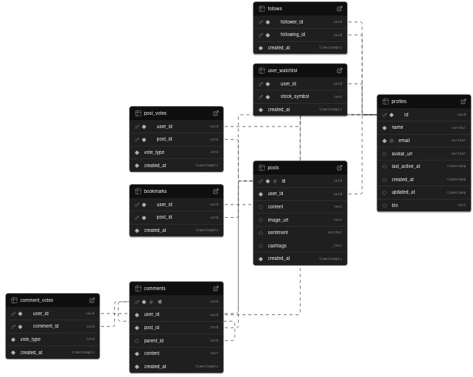



  - Market Metadata Module: This module stores static and semi-static information about listed companies, along with related news and community discussions linked specifically to stock symbols.
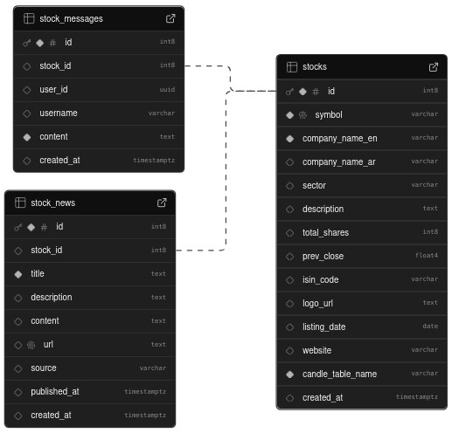

  - Financial Time-Series Module: This module handles high-frequency data for stock charts and commodities (Gold), optimized for time-series querying using partitioned tables.

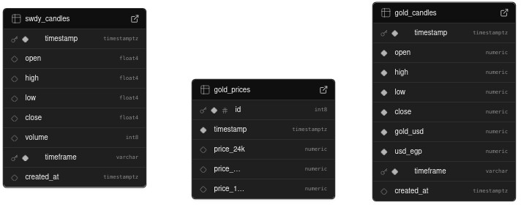



  - Constraints & Design Decisions:
    - Foreign Keys: Rigid relationships are enforced (e.g., stock_messages.stock_id → stocks.id) to maintain data integrity.
    - Dynamic Referencing: The stocks table contains a column candle_table_name to dynamically reference specific candle tables (e.g., swdy_candles) for optimized performance.
    - Security: Row Level Security (RLS) policies are applied to ensure users can only modify their own social data.
- System Architecture (Block Diagram)
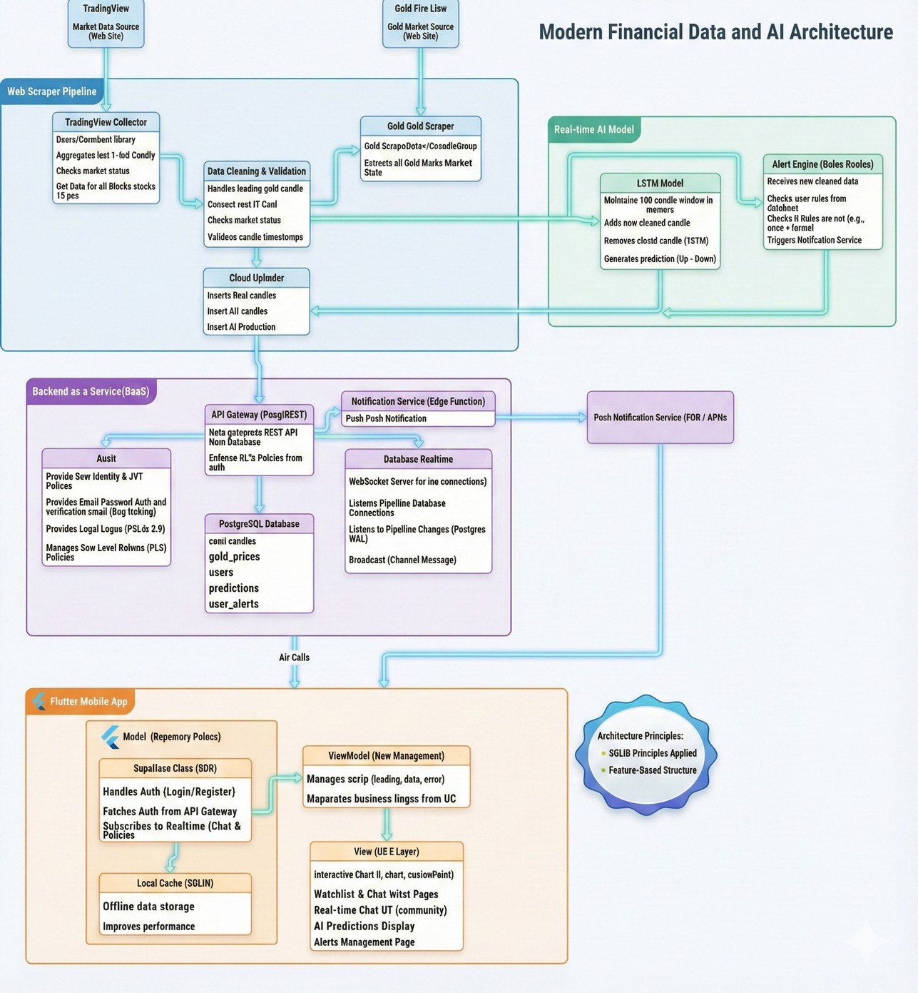
The high-level system architecture illustrates the data flow from the Python Scraper (Ingestion Layer) to Supabase (Storage Layer), and finally to the Flutter Client (Presentation Layer) via WebSockets.
(17)


- Algorithm Design: this pseudo for this part in data Real-Time Data Ingestion
This pseudo-code describes the critical logic of the Python Automation Pipeline designed to fetch live market data and inject it into the specific candle tables shown in the ERD.

BEGIN Data_Ingestion_Pipeline CONNECT to Supabase Client
FETCH active_stocks FROM table "stocks" WHILE (Market_Status == "OPEN") DO:

FOR each stock IN active_stocks:
live_data = API_GET("https://egx-source.com/api/" + stock.symbol) IF live_data IS VALID THEN:
target_table = stock.candle_table_name // e.g., "swdy_candles and another stocks to 25 ” new_candle = {
"open": live_data.open, "high": live_data.high, "low": live_data.low, "close": live_data.close, "volume": live_data.volume, "timestamp": NOW()
}
DB.table(target_table).insert(new_candle) END IF
END FOR
WAIT(1 second) END WHILE
END Data_Ingestion_Pipeline
(18)


3.2 Flowchart this part of only app
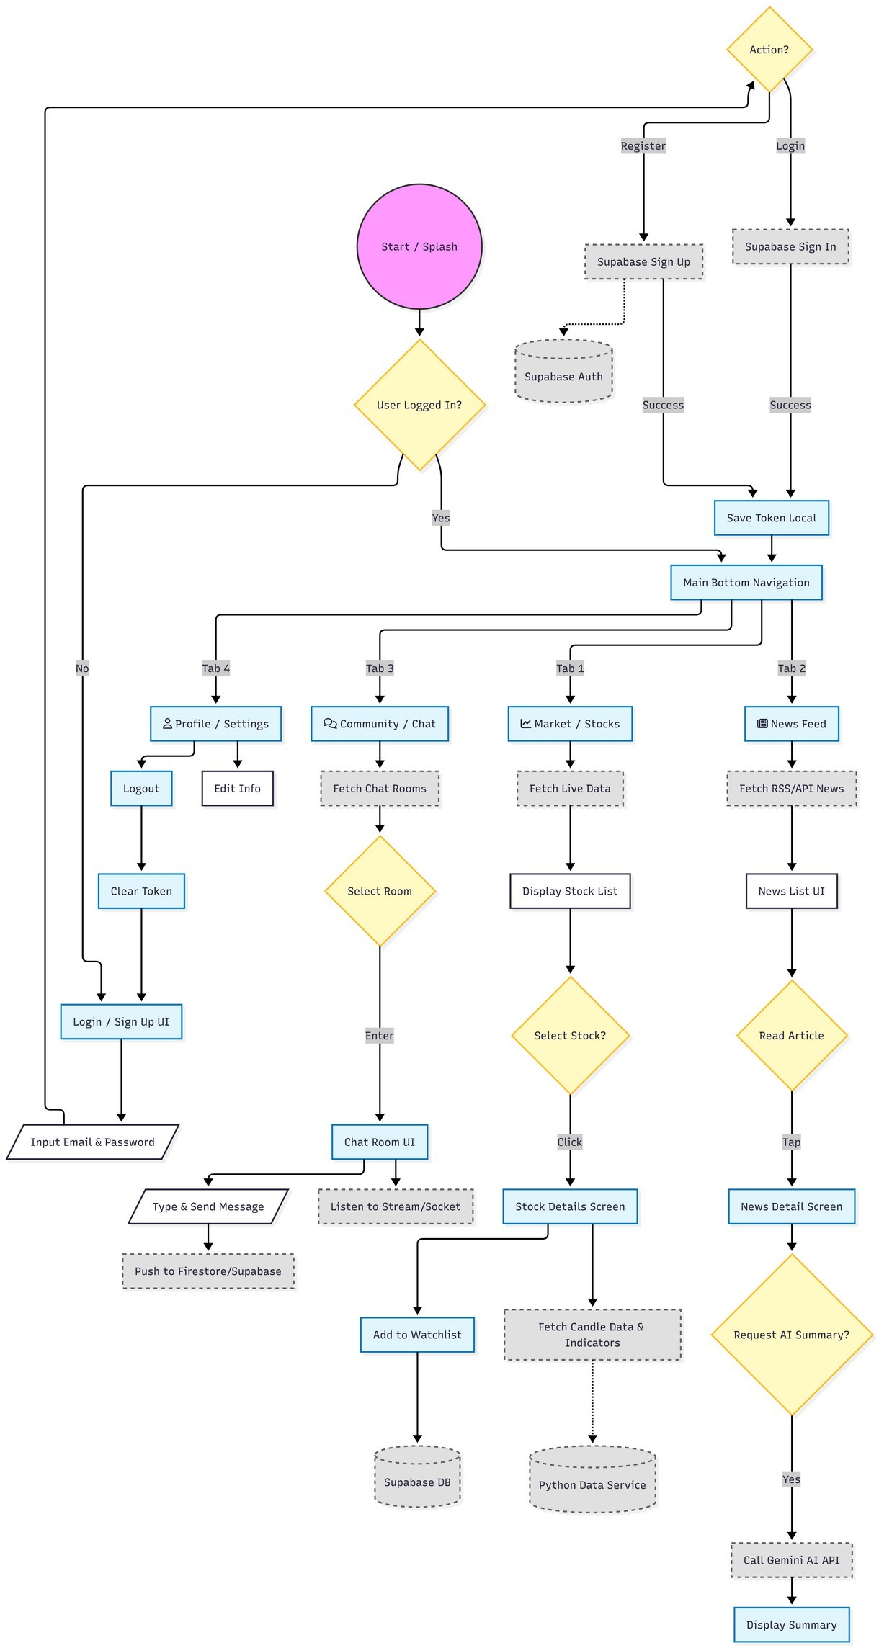



- Software and Modeling Tools Used
The following tools were utilized to construct the initial design and architecture of the system.

Tool Name | Purpose in Project | Why it was used? | Limitations
Supabase Studio | Database Schema Design | Used to generate the visual ER diagrams presented above and define SQL relationships directly in the browser. | Visualization features are auto- generated and offer limited customization for export styling.
Figma | UI/UX Prototyping | Used to design the mobile app interface (Charts, Social Feed) prior to implementation. | Static prototyping only; cannot simulate complex state management or API integration logic.
Draw.io | System Architecture | Used to visualize the data flow between the Python Scraper, Supabase Backend, and Flutter Client. | Purely graphical; does not provide code generation or database validation capabilities.



Question 6: What work do you intend to carry out in the near future

- Work intended to be completed in the near future (Next Week)
  - Based on the completed analysis and design phase, my immediate focus for the next week (Week 9 of the semester) is to move from design to concrete implementation of the Data Layer (Backend & Ingestion).
  - The specific tasks I intend to complete are:
  - Finalize Supabase Schema Implementation: Translate the approved ERD diagrams into actual PostgreSQL tables on Supabase, including setting up foreign keys and defining the initial Row Level Security (RLS) policies for user data.
  - Develop the Python Data Ingestion Script: Implement the pseudo-code/flowchart designed in the analysis stage into a functional Python script that fetches live end- of-day data for the top 30 EGX stocks.
  - End-to-End Pipeline Testing: Successfully run the script to populate the market_candles and stocks tables in Supabase with real, live data for the first time.

- Justification for priority
  - These tasks are designated as the highest priority right now because they form the fundamental "backbone" of the entire EGX360 platform.
  - Data Dependency: The mobile application's core feature (charting) cannot be developed without real historical and live data present in the database.
  - AI Prerequisite: The AI LSTM model requires a significant dataset to begin training. Establishing the ingestion pipeline now ensures we gather enough data by the time we reach the AI development phase.
  - Blocking Factor: Until the backend structure and data flow are proven to work, any frontend development on Flutter would be based on mock data, which risks significant rework later when integrating with the real backend.



- Reference to Project Schedule and Updates (3 marks)
  - Referring to the Gantt Chart previously submitted in the "Project Proposal," these activities fall under the "Phase 3: Backend & Data Implementation" milestone, originally scheduled for Weeks 7-8.
  - Schedule Update: I have updated the project schedule to extend this phase through Week 9.
  - Reason for Update: The initial analysis of the third-party stock market data source revealed unexpected complexities in handling session tokens and rate limiting, requiring more time for research than initially estimated in the proposal.
  - Accommodation: This one-week shift has been accommodated by compressing the allocated time for the "UI Polish Phase" later in the project. The critical path remains achievable within the semester deadline.
